Stage 6 – "Do not seek the treasure"
COURSE DESIGNER: Ike Starnes (Blue Team Shooting Sports)
SCORING: Comstock 14 rounds.
TARGETS: 7 cardboard targets
SCORED HITS: 2 Best hits per carboard will be scored.

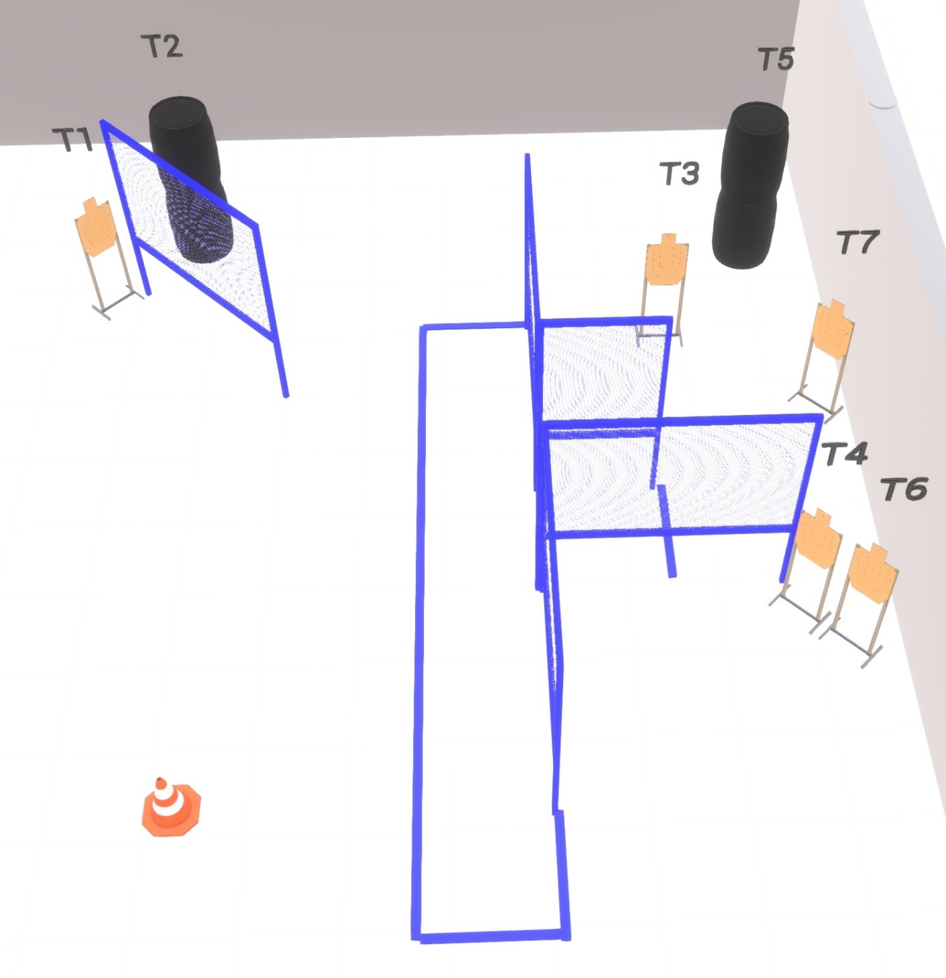

Written Stage Briefing:

Stage 6 – "Do not seek the treasure" - is a 14 round, 70 point, Comstock Course. There are 7 cardboard targets.

Handgun Start position: Facing directly uprange. Toes of both feet touching the rear faultline. Handgun is loaded and holstered. Both hands touching top of head.
PCC Start position: Facing downrange. Heels of both feet touching the rear faultline. PCC is loaded with muzzle pointed at cone. Strong hand touching top of head.

On the audible start signal, engage targets from within the shooting area.

USPSA / NROI Range Commands:
- Make Ready
- Are you ready?
- Standby
- If finished, unload and show clear
- If clear, hammer down and holster (Handgun)
If clear, hammer down and flag (PCC)
If clear, cylinder closed and holster (Revolver)
- Range is clear

Setup Notes:
6 Single Wall Stands
2 Double Wall Stands
4 Full Walls
1 Half Wall
7 Target stands / 14 target sticks
4+ Barrels
1 Traffic Cone



